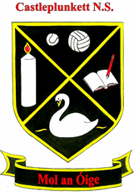
Castleplunkett School

School Calendar
2021 - 2022

Term 1
Thursday 26th August 2021 School Reopens
Monday 25th– Friday 29th October Mid-term Break
Wednesday 22nd December (Half day) Christmas Holidays

Term 2
Thursday 6th January 2022 School Reopens
Monday 21st– Friday 25th February Mid-term Break
Thursday 17th March School Closed – St Patrick’s Day
Friday 18th March School Closed
Friday 8th April (Half day) Easter Holidays

Term 3
Monday 25th April School Reopens
Monday 2nd May School Closed – Bank Holiday
Monday 6th June School Closed – Bank Holiday
Friday 24th June Summer Holidays

